Assignment on Quality. Marketing Class, JJ Cariou
PERFECTION vs IMPERFECTION
We are surrounded by beautiful images with a promise of perfection.
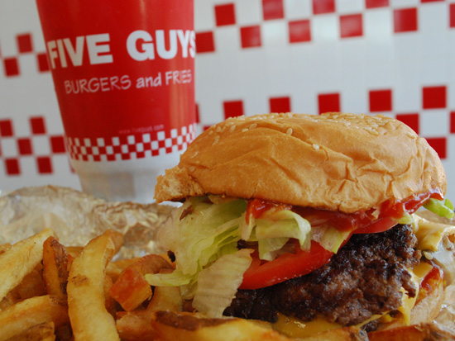
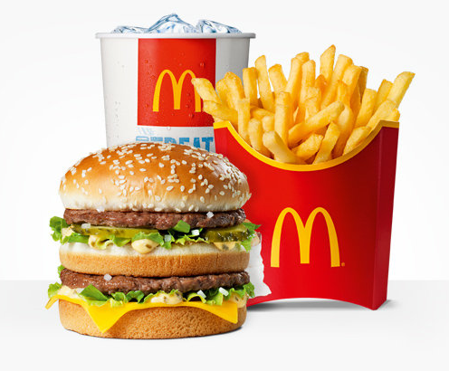
Is the credibility of these images or promises always good? In a marketing context, is “perfection” synonym of “quality”? Is the projection made by consumers from these images distancing him/her from the product or the company? How much is this promise of perfection keeping the consumer from dreaming? …
VS
(Which grandmother do you prefer? Which French fries do you prefer? Why? Ask your neighbor…)
VS

You are working for the (soon to be) « Dreamers Hostel » of Bordeaux, a hotel for backpackers. You are in charge of creating a quality promise based on imperfection.

To DO (including a 5 minute power point or prezi presentation) :
- Give 5 examples from the elements making your product/service relating to the quality promise based on imperfection. Justify your choices in a few words.
- Propose a response message (text SMS) you would use on Hellojam (http://www.hellojam.fr/) to the question « where can I sleep in Bordeaux? ». 160 characters response illustrating your promise.
- Propose a « skyscraper » banner ad (120 x 600 pixels) to be placed on the let’s go web site (http://www.letsgo.com)
Mandatory Logo: (click to download . You need to add your name to the logo)

You have to choose a font for the brand « Dreamers Hostel » to be placed under the logo (see www.dafont.com)

